Advanced Scripting   
Intro

Last Updated: 9/16/2021 8:14 AM Version 1  
Document Prepared for: CIT361 Student

# Name Ryan Skidmore ID 615907798

# Instructions

Save a copy of this document. Use Word to edit and answer all questions directly in this document. You will save and upload this completed document as your homework submission. Make sure you fill out your **Name** and **ID** at the top of the page.

# Overview

This is a test exercise to get you used to working with this format. To answer questions, click in between the red tags and type your answer.

# Setup

If you need a specific setup to do the exercise it will be listed here.

* You will need Microsoft Word on Windows to edit this document, you can get it free from school.

# Task 1—Explore the course outline.

## Steps

1. Read the course outline on Canvas, the link is in the Resources module, then answer the following questions.
   1. What percentage of your grade comes from Exercises? 35%
   2. Do I allow extra credit? No
   3. If yes what are the conditions for extra credit? N/A
   4. What is the late homework policy? Less than 24 hours 10%deduction, 2-7 days 30% deduction, 7+ 100% deduction

# Task 2—Using Teams

For this course we will use Teams to communicate with each other. Here are a few things to keep in mind

1. Post any questions you have in Teams (not as a chat but as a post). This way other classmates can help. If you need to get a classmate’s attention @tag them in the post.
2. If you need to communicate with me privately use a chat with just me.
3. Install the Windows or mobile app to make life smoother.

## Steps

1. Open teams, if you have not installed the app go to your BYUI account on Office 365 and click Teams from the waffle menu  
   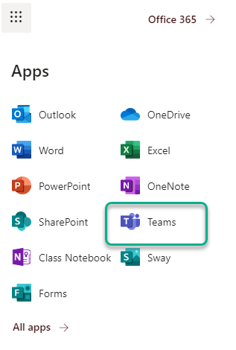
2. Select our class team   
   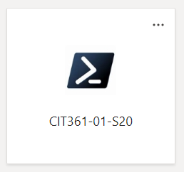
3. If you don’t see our team let me know and I’ll make sure you are added.
4. From the files tab open the **Instructor Intro.pptx** slide deck.  
   Graphical user interface, text, application

   Description automatically generated
5. Answer the following questions.
   1. How many kids do I have? 6
   2. List two of my interests.
      1. Outdoors
      2. Scripting
6. Introduce yourself on teams
   1. . Create a post in the intro channel. It must contain
      1. A bit about yourself.
      2. Tag me.
      3. At least one picture.
   2. Record the link to your post here https://teams.microsoft.com/l/message/19:fb1a4c24b74248979f40917b75cb6f33@thread.tacv2/1641601664765?tenantId=e6ac1d1f-d695-4ef1-91d4-94cddef8be11&groupId=50f71298-734c-4c91-8dcd-bf1dabe05efa&parentMessageId=1641601664765&teamName=CIT-361-02-W22&channelName=Intro&createdTime=1641601664765  
      you can get the link from your post here. Click on your post the select the ellipsis  
      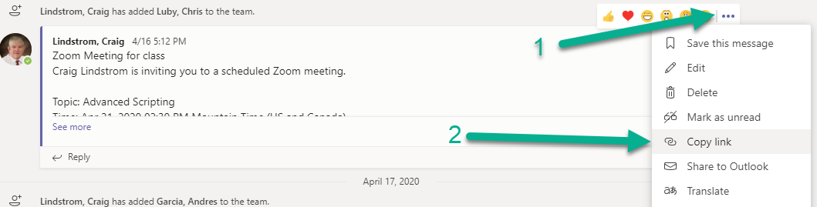

# Deliverable

Upload this document with completed answers to i-learn.